Vendor Web Status
Steps for Vendor Web Status Access
- iNAP Account | Page 1
- IROC Access - Authenticate using eAuth or Login.gov | Page 3
- IROC - Vendor Web Status Request | Page 4
- Statusing Equipment | Page 5
Troubleshooting
- Resetting iNAP password | Page 7
- Helpdesk Information | Page 7
- Helpful links | Page 7
Dispatch – Rejecting wrong type of access requests | Page 7
- If you have completed a step in the past or recently, please go to the next step or whichever step you are on. Many vendors got iNAP and IROC access last year and you only need one account per user, per company.
- Chrome is the preferred browser
1. iNAP Account Request
New Account Request
Navigate to the Integrated National Application Portal (iNAP) website: https://nap.nwcg.gov/NAP/
Click on the person icon and select Request Account. That will bring up the page seen below. Enter the required information and choose Contractor/Vendor for Primary affiliation. Then click Next.
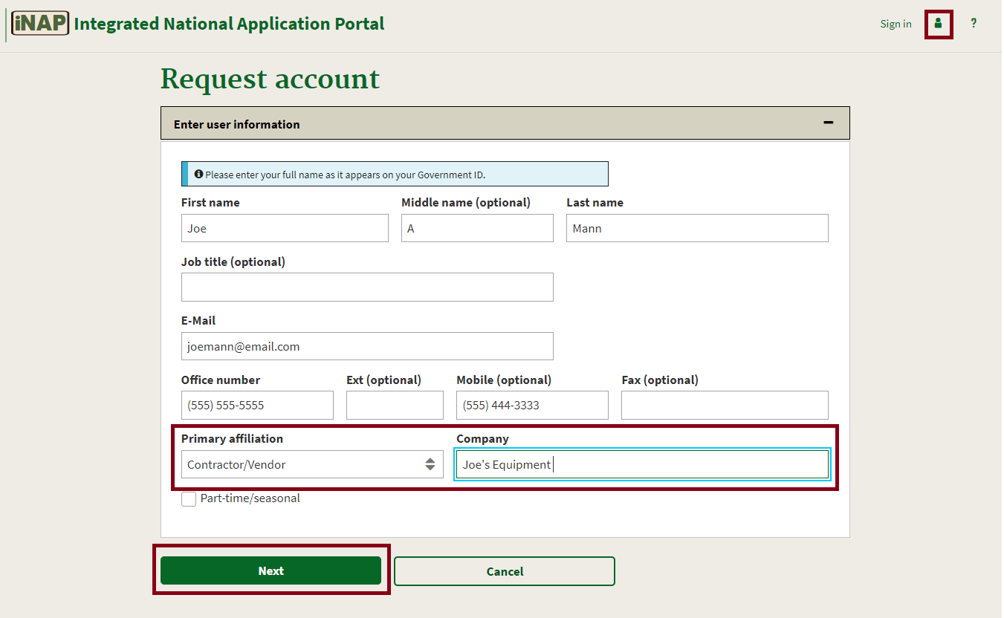
Once you click next, the screen below will expand below the information you have already filled out.
Application Access choose IROC – Interagency Resource Ordering Capability and for the Instance(s) choose PROD (Standard). Enter your contracting officer’s information for the Contacts name, Title, Phone Number, and email. Then click Submit.

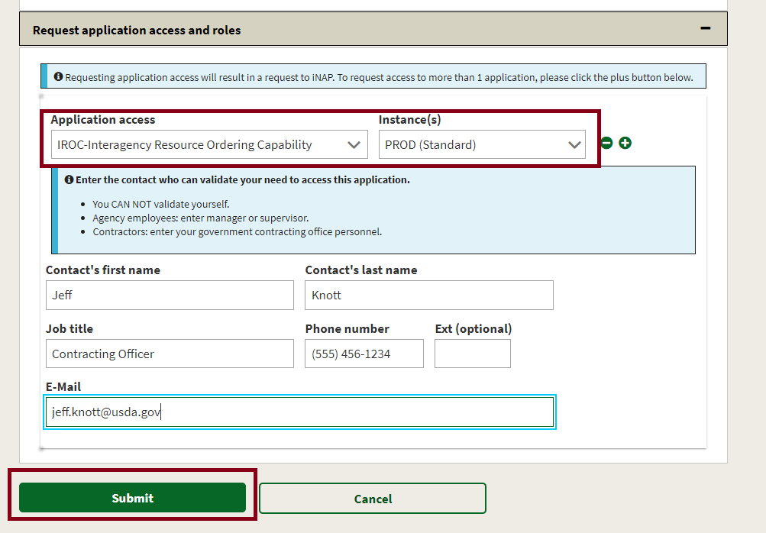

You have now requested your iNAP account and will need to wait for it to be approved. Please note, this can take up to 3 business days to occur. Also, if you do not have an active contract in IROC, your request will not be approved until you have a contract. You will receive an email once your account has been approved, as well as a temporary password, that you will need to change upon your first login.
When you have logged in and changed your password, you should see an IROC tile on the main page. Click on the IROC hyperlink to go to the FAMIT Dashboard (https://iwfirp.nwcg.gov/) Proceed to Step 2.
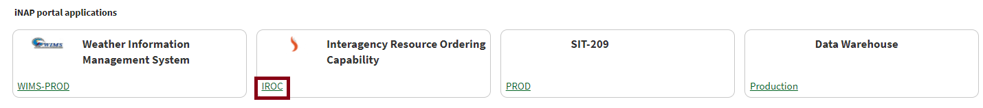

2. IROC Access - Authenticate using eAuthinticate or Login.gov
From the FAMIT Dashboard (https://iwfirp.nwcg.gov/) choose to use either Login.gov or e-Authenticate to login into IROC. See below.
Note: If you do not have either of these types of accounts you will have to request a new one, which you can do by clicking on the links on the FAMIT dashboard. VIPR users will already have an e-authenticate account and can use that account for this process.
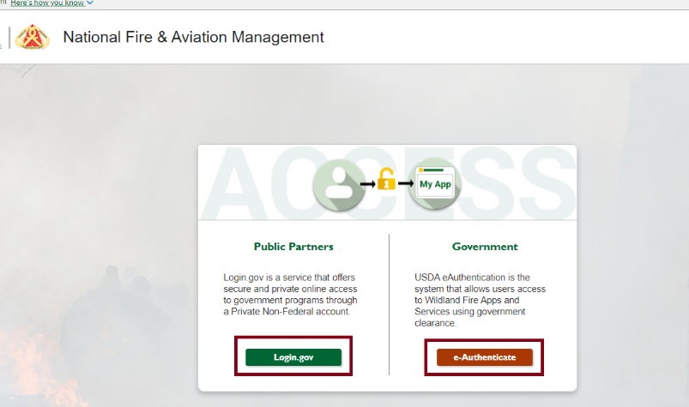
Choose whatever link is correct for you, either Login.gov or e-Authenticate, and login into that account.
After logging in, you will be presented with a tile page of available applications. Click on the IROC tile to launch the application.
Note: The first time you click on the IROC tile, you will be asked to enter your Standard NAP Account credentials. This will link the FAMAuth account to the NAP account. A known error message pops up if you still have another tab with iNAP open while trying to link your iNAP to your Login.gov or e-Auth account. Close the other tab that has iNAP open and you will be able to proceed, however you may need to refresh the browser.
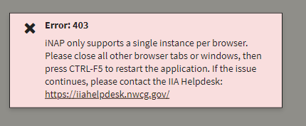
Proceed to Step 3
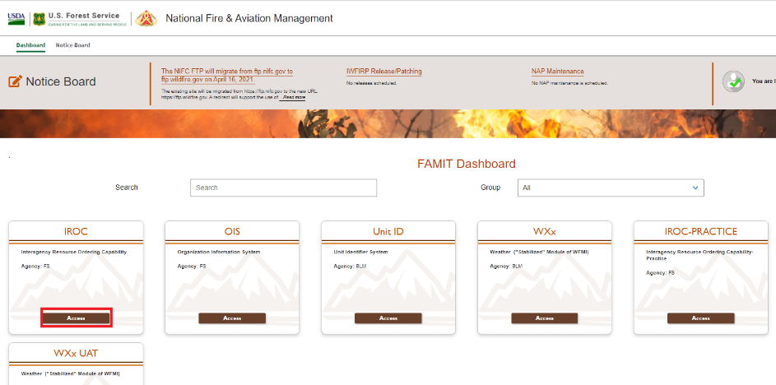
3. IROC - Vendor Web Status Request
Once you have clicked on the IROC tile Access link, the below page will appear. You will need to enter a New Access Request. You can choose from either of the options below to input a new request.
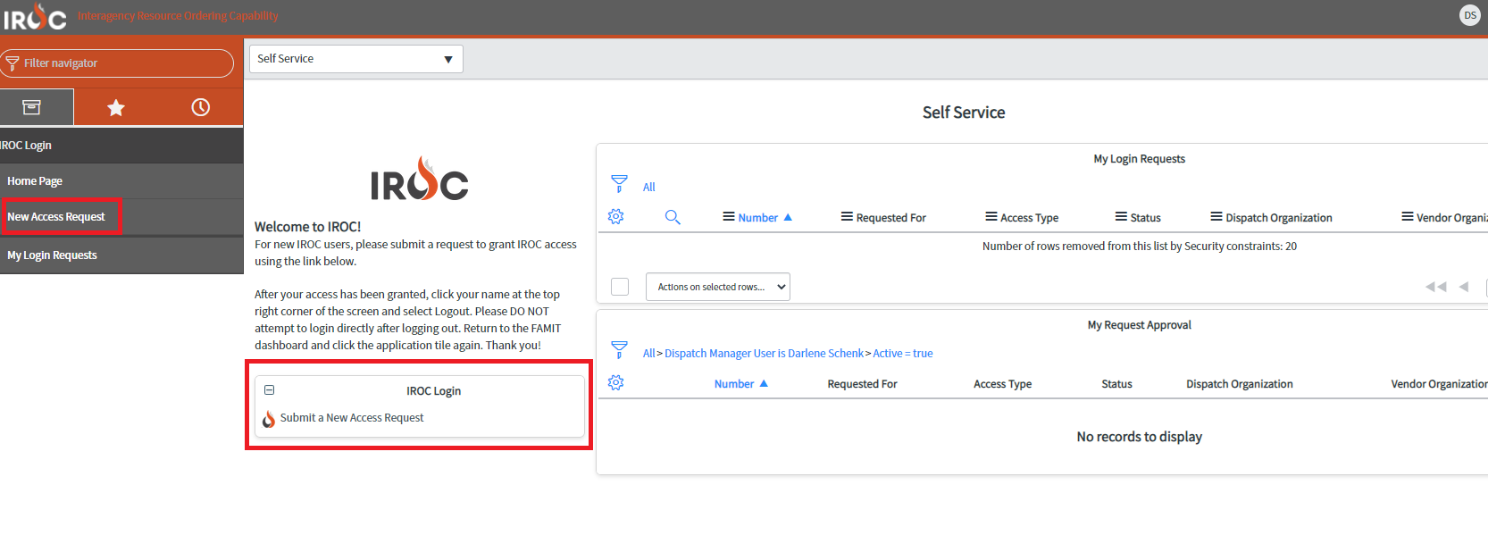
A new screen will fill your screen, see below. Under “Which type of access you’re requesting?” choose Vendor Web Status from the dropdown.
Under the “Please select your vendor organization.”, you can either start typing your company name or you can click on the magnifying glass and look for your company that way. Note: The spacing, punctuation and spelling are all specific, so use the name put on your contract.
You can put in comments if you would like, but that is not required.
Click the Submit button when your information has been entered.
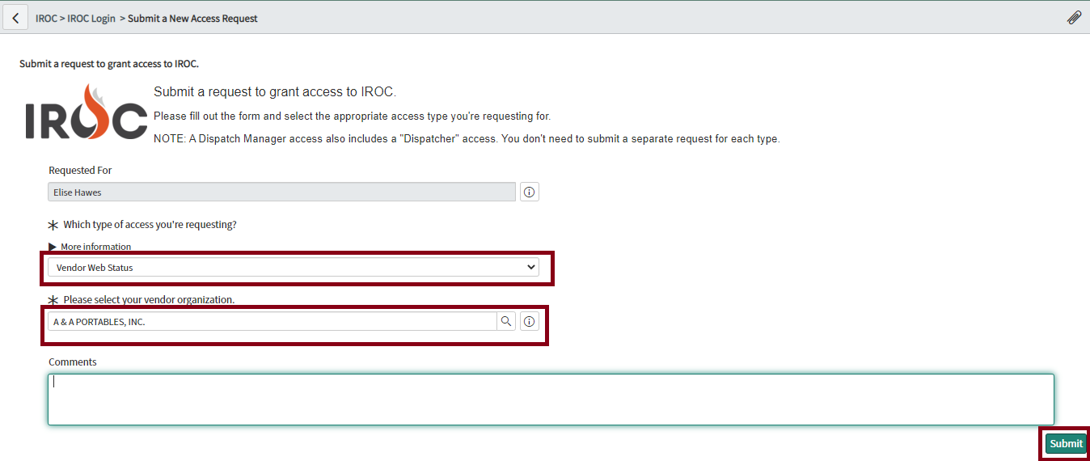
Your request will have to be approved by an IROC SME, not your local dispatch center, to ensure the request is correct and that it isn’t a duplicate. This process can take up to 3 business days. You will get an email when your access request has been approved. Proceed to Step 4.

Statusing Equipment
Once your Vendor Web Status Access request has been approved, login into IROC through the FAMIT Dashboard https://iwfirp.nwcg.gov/index.html with your Login.gov or e-Authenticate account.
You can either use the Filter Navigator at the top left side of the screen to type in the word “Web” and then click on Web Status or you can click on the icon that looks like a file box and choose Web Status. Once you click on Web Status a new option will populate below, Web Status Resource Manager.
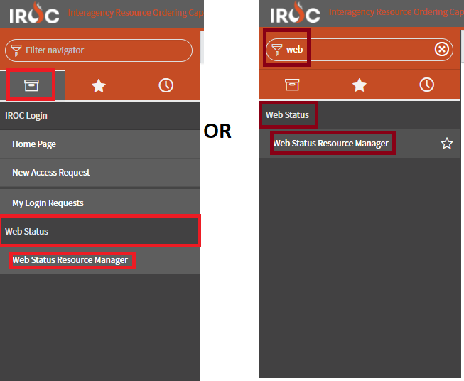
Once you click on Web Status Resource Manager, a new window will pop-up. This is the window that will allow you to status your resources.
You can multi-select equipment using the check boxes on the left side of the screen. Then choose either the Set Available Area button or the Set Resource Status button.
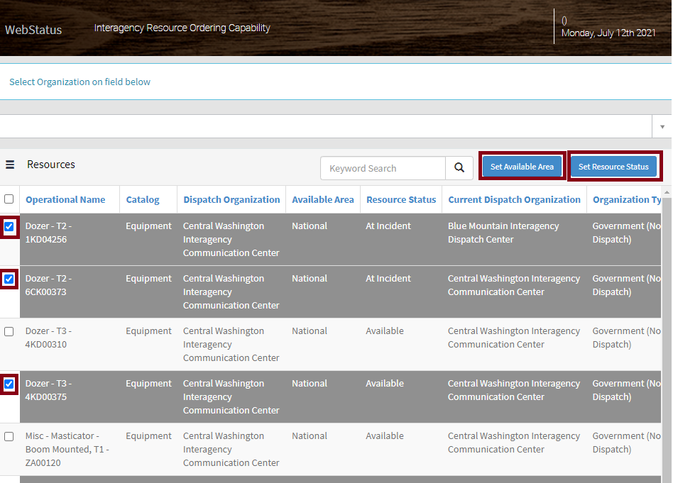
Set Available Area
In the pop-up box, choose Local, State, National, or GACC from the drop-down. Then click Update, and then click close.
- Local – Resource is available to the dispatch area that your resource is contracted under
- State - Resource is available to the state your resource is contracted in
- GACC - Resource is available to the Geographic area your resource is contracted in. Picture of geographic areas below.
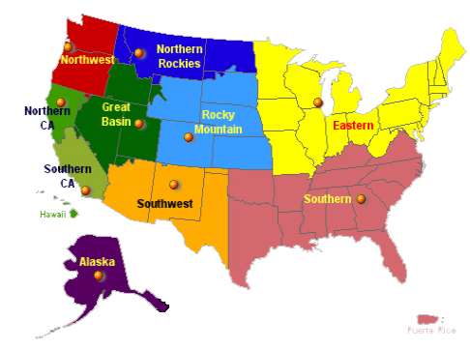
- National - Resource is available to anywhere in the Nation

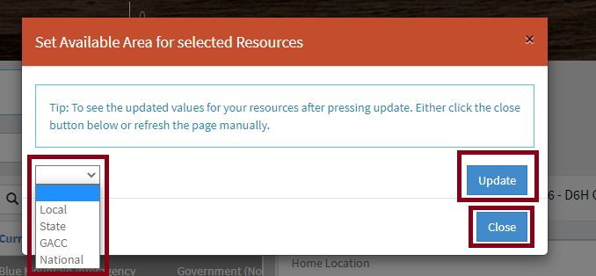
Set Resource Status
In the pop-up box, choose either Available or Unavailable. Then click Update and then Click close.
Note: If your resource is at an incident, mob enroute, demob enroute, etc. it will show that way in resource status and you will not be able to update its availability. If your resource is showing “returned form assignment” it will be unavailable until you change its status.
Note: Some pieces of equipment have more than one contract and can be different types of resources. If that is the case, they will not show up individually, the primary qualification will show in the list of resources but if you highlight the resource and look on the right side of the screen and click the qualifications tab, it will show what that resource is contracted as.
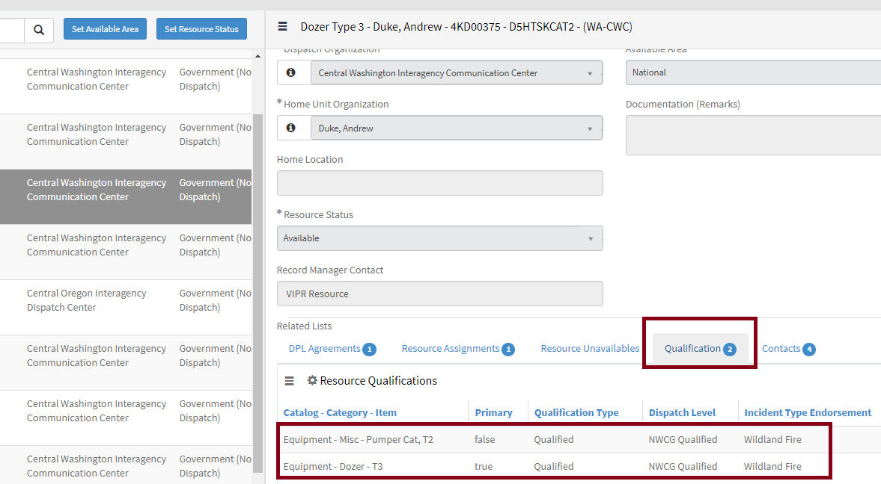

Troubleshooting and Links
Resetting your iNAP password
iNAP requires your password to be reset every 60 days, you will receive email reminders to the email you have on file to update your password before it expires. If you do not update your password in time, your account will be locked, and you will need to contact the IIA helpdesk.
Helpdesk Information
Webpage: https://iiahelpdesk.nwcg.gov/
Toll-Free: 866-224-7677
Helpful Links
iNAP: https://nap.nwcg.gov/NAP/
FAMIT Dashboard: https://iwfirp.nwcg.gov/index.html
Login.gov: https://secure.login.gov/?request_id=1168e209-5984-4102-83df-c1a61a1954f2

Dispatch – Rejecting wrong type of access requests
In DMT, people with Dispatch Manager Access can approve most types of access requests. Sometimes users put in for the wrong type of access. The IROC SME’s approve all vendor requests, so if you get a different type of an access request for a vendor, please reject the request, and ask them to put in for Vendor Web Status. The most common request we have been seeing is, self-status.
In DMT go to the My Organization Approvals. This screen will have access requests that have come in for resources in your center. You will want to look at the ones that have a Status of New.
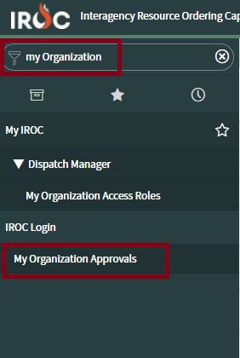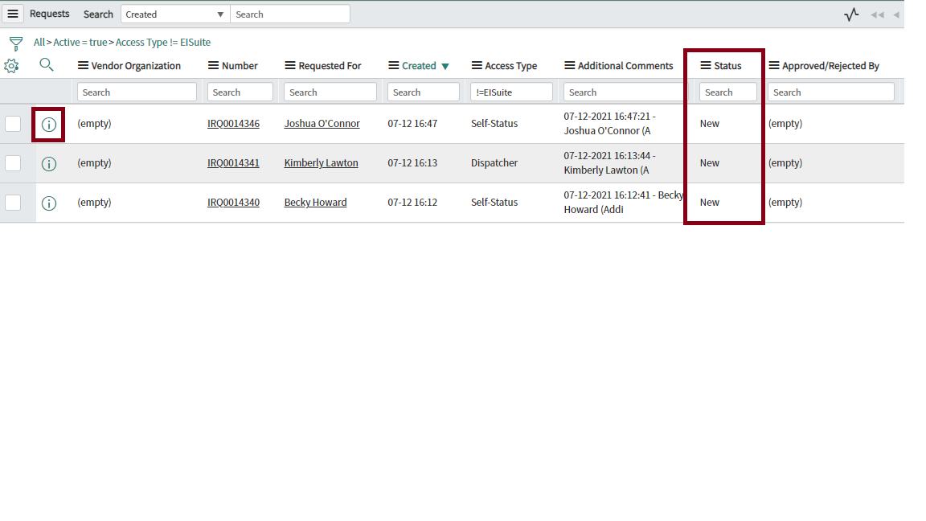
Click on the information icon of the request to manage the request. If a user has requested the correct access you can click the approve button. If they have not requested the correct access use the Additional Comments section to let them know why you are rejecting the request and then click the Reject Request button.
Example for Vendors that request the wrong access to IROC:
It appears you are a vendor, so this request has been rejected. Please submit a new request for Vendor Web Status.
